1. First, install dependencies for both server(React & Node) i.e. for "client folder" and for "server folder" by :
   * **npm install**
2. Once both server dependencies install, run both server separately,
   * GO into directory "cd client" and use command "**npm start**" to start React server
   * GO into directory "cd server" and use command "**npm test**"(for development mode) to start Node server
3. Create a database and create a collection name “users” and import the file users.json in that collection.
4. Open React in browser and it will show you the Login page enter credentials:

* username: Test User1
* 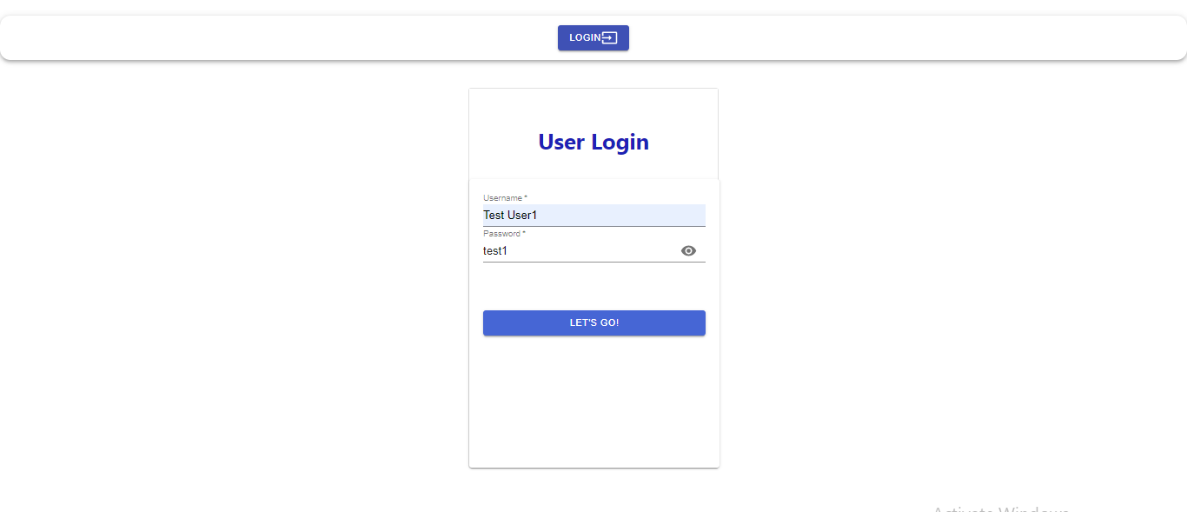password: test1

1. It will open the homepage and will display some list of items you click on details and It will take you to details page where details are rendered and also the charts are displayed there too.

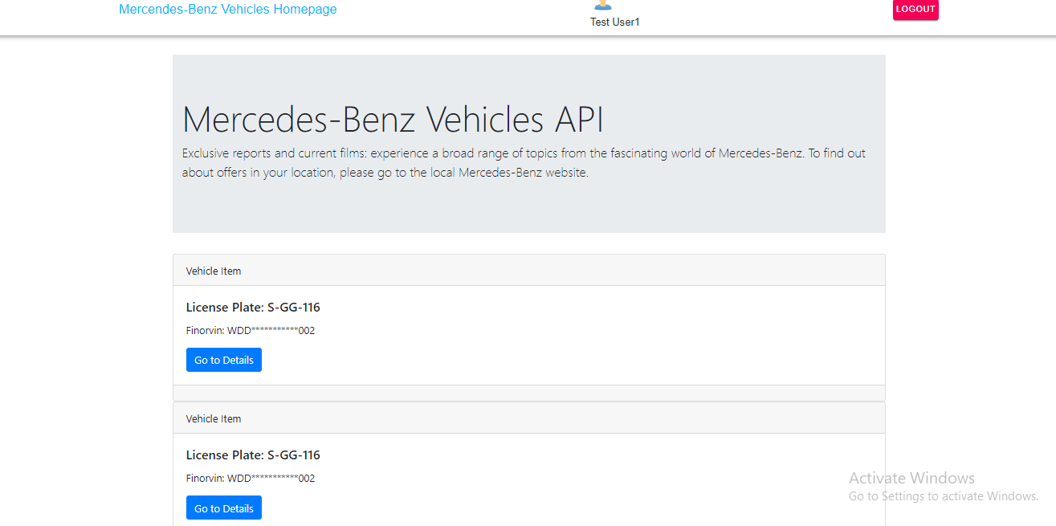

**Note:** You have to run servers concurrently for their functionality to work

1. Configure the settings as per your requirements in “.env” file for server solution.

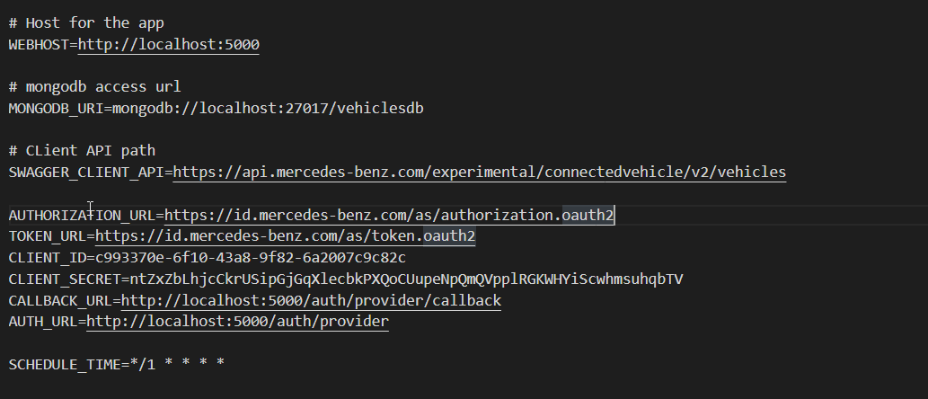

1. Schedule_Time is configured to be at 1 minute for now. To understand please use:

